WEST END UNIVERSITY COLLEGE

DETECTION OF FAKE NEWS

USING MACHINE LEARNING TECHNIQUE.

EUGENE KWAPONG AYE

2021

WEST END UNIVERSITY COLLEGE

DETECTION OF FAKE NEWS

USING MACHINE LEARNING TECHNIQUE.

BY

EUGENE KWAPONG AYE

(WCSC1909002)

Project submitted to the Faculty of Computer Studies, West End University College, in partial fulfillment of the requirement for the award of Bachelor of Science in Computer Science

JULY

2021

# DECLARATION

Candidate’s Declaration I hereby declare that this project is the result of my original study. No part of it has been produced for another degree in any university or elsewhere.

Candidate’s signature: ……………………… Date: ………………………………

Name: KWAPONG EUGENE AYE

Supervisor’s signature:…………………………. Date: …………………………………..

Name:

## ABSTRACT

People rely heavily on the news for information. Detecting false information is a difficult task.

Fake news, as described by the New York Times as "a made-up narrative with the purpose to deceive," is probably one of the most severe issues confronting the news business today.

In today's world of hectic schedules, none of us has the time to double-check the source of every news story. This is a time-consuming and difficult operation. Different forms of false news are a key issue in the propagation of fake news, among all the obstacles.

Fake news is a serious threat that consists of any type of incorrect, inaccurate, or misleading information.

The False News Detection project's objective is to see how machine learning and natural language processing can help with the fake news problem.

## DEDICATION

This project is dedicated to Mr. Alidu Abubakari , Lecturer, Faculty of Computer Studies, and West End University College.

Table of Contents

DECLARATION 2

ABSTRACT 3

DEDICATION 4

CHAPTER ONE 9

Background of the Study 9

Problem Statement 10

Aim 10

Objectives of the study 10

SIGNIFICANCE OF THE STUDY 10

SCOPE OF THE STUDY 11

Fake News Detection 11

Automated Fake News Detection 12

An Approach Using Machine Learning 13

Limitation Of the Study 14

METHODOLOGY 15

CHAPTER TWO 16

LITERATURE REVIEW 16

INTRODUCTION 16

CONTRIBUTORS OF FAKE NEWS 19

CHAPTER THREE 21

METHODOLOGYs 21

INTRODUCTION 21

SIMULATION TOOL 22

DATASET 22

THEORY OF FAKE NEWS DETECTION 25

DATA ENTRY 26

DATA PROCESSING 26

STOP WORD REMOVAL 26

PUNCTUATION REMOVAL 27

STEMMING 28

TF-IDF vectorizer 29

N-Grams 31

Unigram 31

Bigrams 31

Shallow and Deep syntactical Analysis 32

Semantic Analysis 32

Combining features to form final news vector 33

List of Text Preprocessing steps 33

Merging of fake and True data frame 34

Removal of “title”, “subject” and “date” columns 34

Random shuffling of the data frame 34

Convert text into lowercase, removal of extra space, special characters, url and links 34

Defining dependent and independent variable 35

Splitting the dataset into training and testing set 35

Convert text into vectors 35

Classification 35

Naïve Bayes 35

CHAPTER FOUR 38

SIMULATION AND DISCUSSION 38

Performance metrics 38

Accuracy 38

Recall 38

Precision 39

F1-Score 39

DISCUSSION 39

COMPARISON FOR ALL MODELS 40

CONFUSION MATRIX 40

Null Error Rate 41

Cohen's Kappa 41

ROC Curve 41

ACCURACY 43

CHAPTER FIVE 45

SUMMARY, CONCLUSION AND RECOMMENDATION 45

REFERENCES 46

APPENDIX 50

Figure 1 The machine learning process 21

Figure 2 Example fo google colab 22

Figure 3 Sample of training dataset 23

Figure 4 Real and Fake news dataset 24

Figure 5 Data Preprocessing 26

Figure 6 Example of a stop word removal 27

Figure 7 example of punctuation removal 27

Figure 8 Example of steaming 28

Figure 9 Example of bag of words 29

Figure 10 Example of TF-IDF 30

Figure 11 Example of n-grams 31

Figure 12 Example of bigram and unigram 32

Figure 13 Example of a naive bayes 36

Figure 14 Example of gradient boost classifier 36

Figure 15 Example of random forest classification 37

Figure 16 Confusion Metrics 39

Figure 17 Confusion Matrix for multinominal Naive Bayes 42

Figure 18 Confusion Matrix on Gradient Boosting 42

Figure 19 Confusion Matrix for Random Forest 43

Figure 20 Accuracy result of all Models 44

# CHAPTER ONE

## Background of the Study

As an increasing amount of our lives is spent interacting online through social media platforms, more and more people tend to seek out and consume news from social media than traditional news organizations. The reasons for this change in these social media platforms. it is often more timely and less expensive to consume news on social media compared with traditional news media, such as newspaper or television; and it is easier to further share, comment on, and discuss the news with friends or other readers on social media. For example, 62 percent of U.S. adult get news on social media in 2016, while in 2012, only 49 percent reported seeing news on social media. It was found that social media now outperforms television as the major news source.

Despite the advantages provided by social media, the quality of news on social media is lower than traditional news organizations. However, because it is cheap to provide news online and much faster and easier to disseminate through social media, larger volumes of fake news, i.e., those news articles with intentionally false information, are produced online for a variety of purposes, such as financial and political gain.

Fake news can have serious negative impact on individuals and society. Fake news can break the authenticity balance of the news ecosystem. It is evident that the most popular fake news was even more widely spread on Facebook than the most popular authentic mainstream news during the U.S 2016 president election. Fake news intentionally persuades consumers to accept biased or false beliefs. It manipulated by propagandists to convey political messages or influence. Example, some report shows fake news was just created to trigger people’s distrust and make them confused. Technologies such as Artificial Intelligence (AI) and Natural Language Processing (NLP) tools offer great promise for researchers to build systems which could automatically detect fake news.

## Problem Statement

Fake news can be in many forms, including: unintentional errors committed by news aggregator, outright false stories, or the stories which are developed to mislead and influence reader’s opinion. The effect that it can have on people, government and organization may generally be negative since it differs from facts.

In the past decade, social media has become increasingly popular for news consumption

due to its easy access, false dissemination, and low cost. However, social media also

enables the wide propagation of “fake news” i.e., news with the intentionally false

information. Fake news on social media has recently become an emerging research area

that is attracting tremendous attention.

## Aim

To investigate the effectiveness of machine learning algorithms to detect fake news

## Objectives of the study

1. Build a preprocessing technique for cleaning the dataset
2. Evaluating three machine learning algorithms under dataset using different criterial to measure performance of the algorithms.
3. Using different metrics to measure performance of the algorithm

## SIGNIFICANCE OF THE STUDY

We will rely on news content features and exiting factual sources to classify fake news; thus, knowledge-based and style-based.

Social media platforms wield enormous power. The expected daily number of tweets is around 500 million, according to internet live analytics. These platforms are all over the place. They are the preferred setting for exchanging ideas, sentiments, opinions, and intentions. This creates perfect conditions for disseminating news with the fewest possible limits and constraints.

It is common in today's environment to get news via internet sources such as social media. Readers' perceptions of news are frequently subjective. We frequently opt to consume stuff that appeals to our various emotions. As a result, the most widely disseminated information may not be true or accurate news. Furthermore, true news may be twisted during transmission.

## SCOPE OF THE STUDY

### Fake News Detection

The definition of fake news is a challenge in itself. It can say to be a made-up story with

an intention to deceive or news articles that are intentionally and verifiably false, and

could mislead readers or fake news is a type of yellow journalism that consist of

deliberate misinformation or hoaxes spread via traditional and broadcast news media or

online social media.

The core task of detecting fake news involves identifying the language (set of words or

sentences) which is used to deceive the readers. with the ever-increasing popularity of

social media sites, user-generated messages can quickly reach a broad audience. Thus,

social media has become an ideal place for fake news propagation. Fake news reaching a

broad audience can cause elevated societal harm and economical damages and example,

during 2016 U.S. Presidential election, the most discussed fake news tended to favor

Donald Trump over Hillary Clinton (Silverman, 2016). Thus, some commentators have

suggested that Donald Trump would not have been elected president were it not for the

influence of fake news (Allcott & Gentzkow).

Fake news identification often entails using all of the techniques and procedures available to validate the information. It could entail going to fact-checking websites. It could be crowdsourcing validated news in order to compare it to unconfirmed news. However, the amount of data collected on a daily basis on the internet is staggering. Given how quickly information circulates on the internet, manual fact-checking can be done swiftly.

### Automated Fake News Detection

Automated detection systems are beneficial in terms of scalability and automation. Fake news detection research employs a variety of methodologies and approaches. It's also worth mentioning that, depending on one's point of view, these techniques frequently overlap. In my opinion, there are only two approaches worth discussing.

These two approaches concentrate on the methods used rather than the material being studied. Natural Language Processing (NLP) may be used in both of their approaches.

Natural Language Processing allows computers to interpret and respond to natural/human language. As a result, there are two elements to consider:

* Natural Language Understanding

Gartner defines Natural Language Understanding (NLU) as "computers understanding the structure and meaning of human language (e.g., English, Spanish, Japanese), allowing users to engage with the computer using natural phrases." In other terms, NLU is a form of artificial intelligence that interprets text and other unstructured data using computer software. NLU is capable of digesting a text, translating it into computer language, and producing an output in a human-readable language.

* Natural Language Generation

NLG is a software technique that automatically converts data into plain-English content. It is a subfield of artificial intelligence (AI). By creating the words and paragraphs for you, the technology may really create a tale that is identical to that of a human analyst. NLG is one of the most rapidly gaining traction in the business world. NLG has a wide range of applications, but it is most successful when used to automate time-consuming data processing and reporting tasks.

The two approaches to fake news detection are:

* Machine Learning approach
* Deep Learning approach

### An Approach Using Machine Learning

Giving computers the ability to learn without being explicitly programmed is referred to as machine learning. To detect misinformation, a machine learning technique use machine learning algorithms. The following are some examples of these algorithms:

* Multinominal Naïve Bayes

The Bayes theorem is the foundation of Naive Bayes, which states that features in a dataset are mutually independent. The occurrence of one trait has no bearing on the likelihood of the occurrence of the other. Nave Bayes can outperform the most powerful alternatives for small sample sets. It is employed in a variety of fields due to its relative robustness, ease of implementation, speed, and accuracy.

* Random Forest Classification

A random forest is nothing more than a collection of decision trees. Overfitting is not a problem with random forests. You are free to plant as many trees as you like. It is quick. On an 800Mhz computer, it created 100 trees in 11 minutes using a data set with 50,000 cases and 100 variables. The storing of the data itself, as well as three integer arrays with the same dimensions as the data, is the primary memory need for big data sets. When proximities are determined, the number of cases times the number of trees equals the storage needs.

* Gradient Boost Classification

The Gradient Boosting Machine, or GBM, generates final predictions by combining predictions from many decision trees. Keep in mind that in a gradient boosting machine, all of the weak learners are decision trees.

The algorithms are refined using datasets. These datasets can be divided into two categories: training data and test data. A lot of studies use a combination of machine learning techniques and data mining. This is a common practice on social media networks, particularly Twitter data. A model might, for example, use Nave Bayes, Support Vector Machines (SVM), and Natural Language Processing (NLP) to detect fake news.

The two classifiers can be applied to a dataset and their performance compared depending on the nature of the data. These classifiers, on the other hand, can be utilized in an ensemble technique to improve model accuracy by enhancing each other's performance in classification tasks.

Data is divided into two categories by SVM. These categories are likely to be "true" or "false" in the sense of detecting fake news. It's also a fairly adaptive algorithm that works well with semi-structured datasets. As a result, combining SVM and Nave Bayes is successful for detecting bogus news.

NLP could be used to extract features from data. It could also be useful when attempting to contextualize text data, which is a difficult task for typical machine learning algorithms. Given that sentiment analysis is a specialization of NLP, NLP may also be used to analyze data sentiment.

## Limitation Of the Study

The problem's constraints include the fact that the data is irregular, which means that any form of prediction model can have errors and make mistakes.

## METHODOLOGY

The proposed fake news detection model consists of four major components, namely Naïve Bayes, Gradient Boost Classification and Random Forest classification which are integrated together to detect fake news at the early stage of its propagation.

# CHAPTER TWO

## LITERATURE REVIEW

## INTRODUCTION

World is changing rapidly. The expansion of social network has brought about the epidemic of fake news which is in contrast to traditional mass media such as newspapers, magazines, radio and television. (de Oliveira, Pisa, Lopez, de Medeiros, & Mattos, 2021) No doubt there are different issues in this digital world. One of them is fake news. Social media news consumption is a double-edged sword that is low cost, easy access and rapid dissemination of information lead people to seek out and consume news form social media. The good aspect is, it enables the wide spread of “fake news” i.e., low quality news with intentionally false information. The spread of the fake news has the potential for negative impact on individuals and society.

At least in the sphere of spam detection, the problem of recognizing non-genuine information sources by content-based analysis is thought to be solvable. Spam detection use statistical machine learning approaches to determine whether content (such as tweets or emails) is spam or not. Text pre-processing, feature extraction (i.e., a bag of words), and feature selection based on which features lead to the greatest performance on a test dataset are all part of these techniques. These features can then be categorized using classifiers such as Nave Bayes, Support Vector Machines, TF-IDF, and K-nearest neighbors. These classifiers are all supervised machine learning classifiers, which means they're all supervised.

$$f\left(message,θ\right)=\frac{Cspam }{Creg }\frac{if classified as spam}{otherwise}$$

where m is the message to be categorized and is a parameter vector, and Cspam and Cleg are spam and legitimate messages, respectively. In that both try to separate examples of genuine text from examples of illegitimate, ill-intended texts, the challenge of detecting fake news is similar and almost analogous to the task of spam identification. The challenge then becomes how we can apply comparable techniques to the detection of bogus news. Instead of filtering spam, it would be good to be able to mark phony news stories so that readers are aware that what they are reading is most likely fake news.

Various researchers have attempted solving this challenge in a multitude of ways to test which method works and get desirable results. A few studies have discussed fake news detection approaches from a data mining perspective, including feature extraction and model construction. A methodology of feature extraction (both news content features

and social context features) combined with metric evaluation using precision, recall and f1 scores has proved to bear educated results but the problem is not that simple.

News published online in an unstructured format (such as news, articles, videos, and audios) is relatively difficult to detect and classify as this strictly requires human expertise. However, computational techniques such as natural language processing (NLP) can be used to detect anomalies that separate a text article that is deceptive in nature from articles that are based on facts

Fake news is intentionally written to mislead readers to believe false information, which makes it difficult and nontrivial to detect based on news content; therefore, we need to include auxiliary information, such as user social engagements on social media, to help make a determination. Second, exploiting this auxiliary information is challenging in and of itself as users' social engagements with fake news produce data that is big, incomplete, unstructured, and noisy. (Shu, Amy, Suhang , Tang, & Huan)

Fake news and its cousins are not new. One historical example is the “Great Moon Hoax,” of 1835, in which the New York Sun published a series of articles about the discovery of lie on the moon. A recent example is the 2006 “Flemish Secession Hoax,” in which the Belgian public television station reported that the Flemish parliament had declared independence from Belgium, a report that a

large number of viewers misunderstood as true. Supermarket tabloids such as the

National Enquirer and the Weekly World News have long trafficked in a mix of partially

true and outright false stories. (Allcott & Gentzkow, 2017)

Clickbait lure users and entice curiosity with flashy headlines or design to click links to increase advertisement revenues, the interface has the ability to discern useful information from the internet services especially when news become critical for decision making. (Aldwairi & Alwahedi, 2018)

Machine language is the language that is understood by a computer. This is the only thing a computer can understand. All programs and programming language eventually generate or run programs in machine language. (Schmit, 2015)

The most important reason for the persistence of incorrect information is that humans are susceptible to Truth-Bias, Nave Realism, and Confirmation Bias.  When it comes to persons who are innately "truth-biased," This means they have "the presumption of truth" in their favor.  “The inclination to judge an individual based on their social interactions” This assumption is based on the premise that the interpersonal message is true is only likely to be altered if something in the circumstance changes elicits suspicion (V, 2017)

Humans are, in essence, very bad lie detectors and a lack of awareness that there is a problem is the risk that they are being deceived. The majority of users of social media are unaware that there are posts. tweets, articles, or other written publications containing the phrase sole purpose of influencing others' beliefs in order to influence others' views in order to influence others' beliefs in order to influence others' beliefs alter the way they make decisions Manipulation of data is a crime. It's not a well-understood subject, and it's often avoided, especially when false information is spread. Users are prone to lowering their guard when it comes to a friend recommendation and could maybe absorb all of the misleading information on social media as it were the truth. This is also even more detrimental considering how young users tend to rely on social media to inform them of politics, important events, and breaking news (V, 2017).

In addition, people tend to believe that their own views on life are the only ones that are correct and if others disagree then those people are labeled as “uniformed, irrational, or biased,” otherwise known as Naïve Realism (Shu, Amy, Suhang , Tang, & Huan)

This leads to the problem of Confirmation Bias, which is the notion that people favor receiving information that only verifies their own current views. Consumers only want to hear what they believe and do not want to find any evidence against their views. For instance, someone could be a big believer of unrestricted gun control and may desire to use any information they come across in order to support and justify their beliefs further.

It is only those who strive for certain academic standards that may be able to avoid or limit any biasness, but the average person who is unaware of false information to begin with will not be able to fight these unintentional urges.

In addition, not only does fake news negatively affect individuals, but it is also harmful to society in the long run. With all this false information floating around, fake news is capable of ruining the “balance of the news ecosystem” (Shu, Amy, Suhang , Tang, & Huan)

## CONTRIBUTORS OF FAKE NEWS

While many social media users are very much real, those who are malicious and out to spread lies may or may not be real people. There are three main types of fake news contributors: Lies and half-truths may be spread throughout the internet by cyborgs, trolls, and bots. Understanding them is essential for understanding how misinformation spreads on the internet.

As the 2016 election demonstrated, social media is increasingly being used to spread false information and divide Americans on contentious subjects such as race and immigration.

Many of them are innocuous, sending out odd poetry or pet photographs via Twitter. Others, on the other hand, are up to nothing good and are intended to seem like real people.

The development of harmful accounts is not discouraged due to the low cost of creating social media accounts.

Even the finest researchers have trouble detecting bots.

"We have 12 methods to detect a bot, and if we hit seven or eight of them, we have very high confidence," said Graham Brookie, director of the Atlantic Council's Digital Forensic Research Lab in Washington, D.C.

# CHAPTER THREE

## METHODOLOGYs

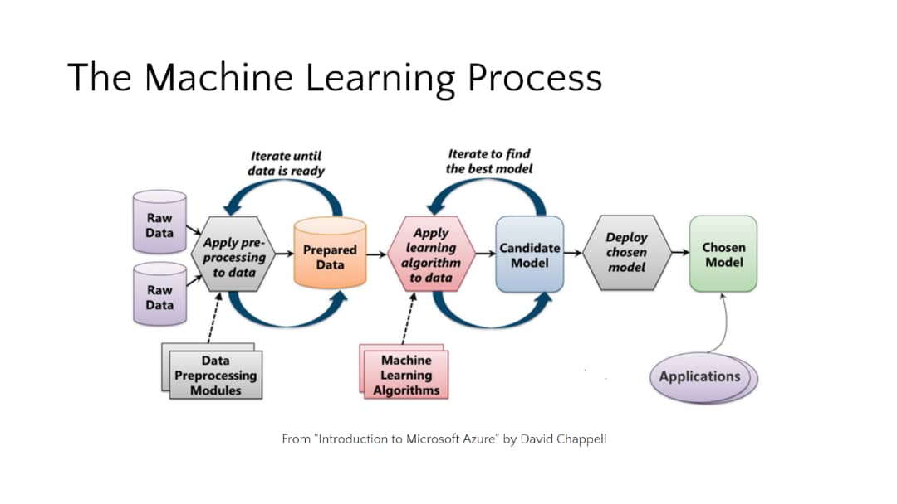

Figure 1 The machine learning process

## INTRODUCTION

This chapter elaborates the methodology adopted to achieve the intended objectives of the study. As illustrated in figure 1,

Machine learning has offered computers a wide range of new capabilities, from cancer analysis to movie prediction.

A "Model" is the system that automates this process, and the model is organized using the "Training" approach. To build an accurate model, we must first ask questions about the data, which necessitates data collection.

Collaborative Filtering is a related application to Search Engine Optimization. This information is heavily used by online bookshops like Amazon and video rental services like Netflix to persuade consumers to purchase further items.

Data normalization is the process by which analysts and scientists transform their unstructured data into a usable format and extract insights from it. These insights are gathered following data preparation, which includes the removal of any missing or incomplete data.

Minimizing an arbitrary function is difficult in general, but when the objective function to be lowered is convex, things get a lot easier. Data is used in many current applications.

## SIMULATION TOOL

Google Colab is a cloud-based Jupyter notebook environment that is free to use. Most importantly, it doesn't require any setup, and the notebooks you create may be changed concurrently by your team members, much like Google Docs pages. Many common machine learning libraries are supported by Colab and can be quickly loaded into your notebook.

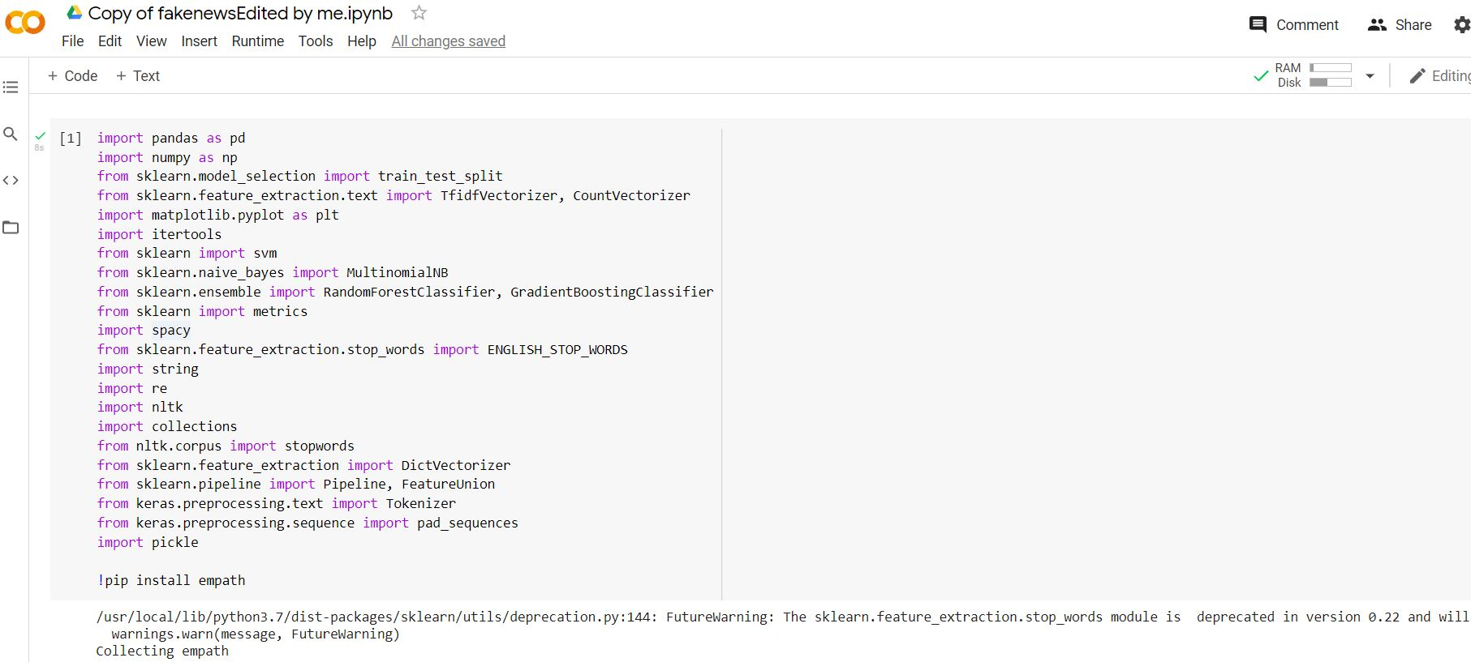

Figure 2 Example fo google colab

(colab, n.d.)

## DATASET

We have 2 datasets for fake news detection, we will use the required attributes of

these datasets to train our model.

* Getting Real about Fake News Dataset- kaggle (Risdal, n.d.)

It contains text and metadata scraped from 244 websites tagged as "bullshit" by the [BS Detector](https://github.com/selfagency/bs-detector) Chrome Extension.

The B.S. Detector is powered by Opensource, a professionally curated list of unreliable or otherwise questionable sources. We no longer maintain our own dataset. Neither the B.S. Detector nor the Self Agency LLC assume liability for the accuracy of Opensource' data. To suggest or dispute a site's inclusion, file an issue with Opensource.

Example domain classifications (in flux) include:

* **Fake News:** Sources that fabricate stories out of whole cloth with the intent of pranking the public.
* **Satire:** Sources that provide humorous commentary on current events in the form of fake news.
* **Extreme Bias:** Sources that traffic in political propaganda and gross distortions of fact.

News may be found online from a variety of places, including news agency homepages, search engines, and social networking websites. Manually assessing the authenticity of news, on the other hand, is a difficult process that generally necessitates domain experts who undertake rigorous examination of claims, supplementary evidence, context, and reporting from sources.

sources that are trustworthy Expert journalists, fact-checking websites, industry detectors, and crowdsourced employees are all common sources of news data with annotations.

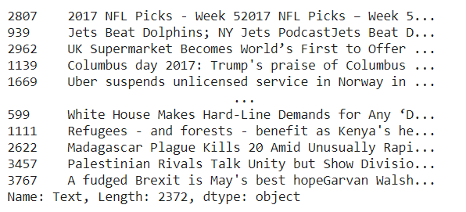

Figure Sample of training dataset

(colab, n.d.)

The Getting Real about Fake News Dataset includes text and information from 244 websites, totaling 12,999 postings over the last 30 days. Because the data was gathered via the webhose.io API, not all of the websites recognized by the BS Detector are included in this dataset. As stated below, each webpage was tagged using the BS Detector. Data sources that lacked a label were simply given the label "bs." Don't believe anything you read because there are (ostensibly) no authentic, reputable, or trustworthy news sources represented in this dataset (so far).

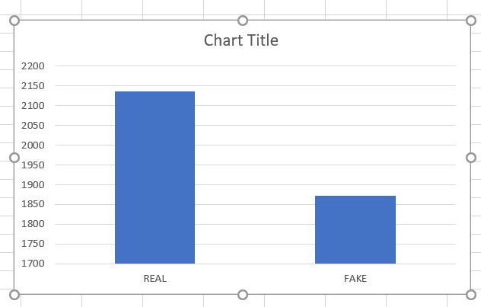

Figure Real and Fake news dataset

* Fake News Detection Dataset- kaggle (Club, 2017)

This is an inclass competition on Kaggle which consist of fake and real news data. It consists of a training dataset and a test dataset with the following attributes;

train.csv: A full training dataset with the following attributes:

id: unique id for a news article

* ztitle: the title of a news article
* author: author of the news article
* text: the text of the article; could be incomplete
* label: a label that marks the article as potentially unreliable
  + 1: unreliable
  + 0: reliable

test.csv: A testing training dataset with all the same attributes at train.csv without the label.

## THEORY OF FAKE NEWS DETECTION

Knowledge-based: The most straightforward means of detecting a fake news is to check the truthfulness of major claims in a new article to decide the news veracity. This is aim to use external sources to fact-check proposed claims in news content. The goal is to assign a truth value to a claim in a particular context. Existing fact-checking approaches can be grouped as expert-oriented, crowdsourcing-oriented and computational-oriented.

Expect-oriented fact-checking relies on human experts to investigate relevant data and documents to construct the verdicts of claim veracity. However, this is time consuming and intellectually demanding.

* Crowdsourcing-oriented fact-checking exploits the “wisdom of crowd” to enable normal people to annotate news content. These annotations as then aggregated to produce an overall assessment of the news veracity.
* Computational-oriented fact-checking aims to provide an automatic scalable system to classify true and false claims. Previous computation-oriented fact checking methods try to solve two majors’ issues. Identifying check-worthy claims and discriminating the veracity of fact claims.
* Style-based: These approaches try to detect fake news by capturing the manipulators in the writing style of news content. There are two typical categories of style-based methods: Deception-oriented and Objectivity-oriented.
* Deception-oriented stylometric methods capture the deceptive statements or claims from news content. The motivation of deception detection originates from forensic psychology (i.e., Undeutsch Hypothesis) and various forensic tools including Criteria-based Content Analysis and Scientific-based Content Analysis have been developed.

Objectivity-orientedapproaches capture style signals  
that can indicate a decreased objectivity of news content and thus the potential to mislead consumers, such as hyperpartisan styles and yellow-journalism. Hyperpartisan styles represent extreme behavior in favor of a particular political party, which often correlates with a strong motivation to create fake news. Linguistic based features can be applied to detect hyperpartisan articles.

## DATA ENTRY

The datasets we used in this study are open source and freely available online. The data includes both fake and truthful news articles from multiple domains. The truthful news articles published contain true description of real-world events, while the fake news websites contain claims that are not aligned with facts. The conformity of claims from the politics domain for many of those articles can be manually checked with fact checking websites such as politifact.com and snopes.com.

Figure 5 Data Preprocessing

### DATA PROCESSING

To use machine learning or deep learning algorithms on text data, specific preprocessing is required. To transform text data into a form that may be utilized for modeling, a variety of approaches are frequently employed. Both the headlines and the news articles are subjected to the data preparation methods outlined below. We also give details on the various word vector formats we utilized in our research.

## STOP WORD REMOVAL

We begin by eliminating stop words from the given text data. Stops Because they are more prevalent and provide less valuable information, words (the most common words in a language that do not give much context) may be processed and filtered from the text.

Stop words, such as conjunctions like "and," "or," and "but," prepositions like "of," "in," "from," "to," and the articles "a," "an," and "the," behave more like a linking component of the sentences. Stop words that are less important might waste processing time, thus eliminating them as part of data preparation is an important initial step in natural language processing.

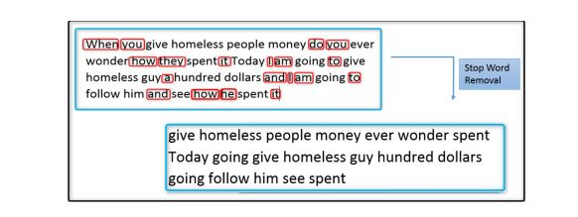

Figure 6 Example of a stop word removal

(Lakshmikumar, 2019)

### PUNCTUATION REMOVAL

Punctuation in natural language gives the phrase grammatical context.

Punctuation, such as a comma, may not add much to the comprehension of the sentence's meaning.

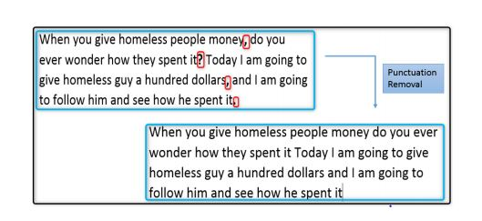

Figure 7 example of punctuation removal

(Lakshmikumar, 2019)

## STEMMING

Stemming is the process of removing prefixes and suffixes from a word until just the stem remains. We can reduce inflectional and occasionally derivationally related variants of a word to a common base form by using stemming. Figure 4 depicts a stemming process in action.

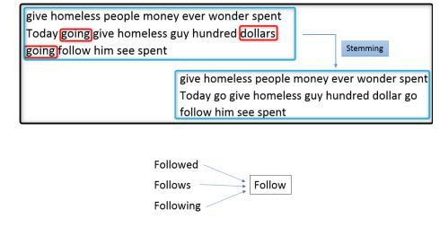

Figure 8 Example of steaming

(Lakshmikumar, 2019)

**Word Vector Representation**

It's difficult to prepare the text for modeling from the news article's body and title. We must transform raw text into numerical characteristics in order to do text analytics. To convert the raw text and extract features, we tried two different techniques: TF-IDF with Bag of Words

**Bag of Word**

The Bag of Words (BoW) approach treats each news story as a document and calculates the frequency count of each word in that document, which is then used to generate numerical representations of the data, also known as fixed-length vector features.

Bag of Words uses the CountVectorizer function to convert raw text to a word count vector for feature extraction. CountVectorizer separates the text from the content, creates a vocabulary, and converts the text to a vector. As a key value pair, this encoded vector will include a count for occurrences of each word that looks more like a frequency count. There are disadvantages to this technique in terms of information loss. The relative location of the words is not taken into account, and context information is lost.

When contrasted to the gain in computational simplicity with the convenience of use, this loss might be costly.

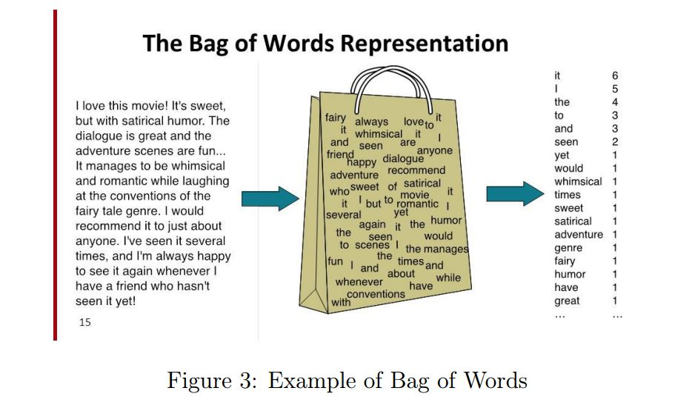

Figure 9 Example of bag of words

## TF-IDF vectorizer

For feature extraction, we utilized the "Term Frequency-Inverse Document Frequency" (TF-IDF) method. The TF-IDF has two components: Term Frequency and Inverse Document Frequency. The frequency with which a word appears in a document determines its local relevance. The signature words that do not occur more often across documents are identified using Inverse Document Frequency.

A signature word with a high TF-IDF is one that is essential for the document in question, has a high frequency in the document, but is not frequent in other texts.

1. TF (Term Frequency): Term frequency is defined as the frequency of a word in the document. TF is calculated as: TF(w) = (Number of times word ‘w’ appears in the document) / (Total number of words in the document).
2. IDF (Inverse Document Frequency): These measures how important a word is in the document. For example, words like and, of, the, a appears lot of times but they are less important. Thus, most repeated terms are given less weights and less frequent terms are given more weights. IDF is calculated as: IDF(w) = loge (Total number of documents / Number of documents with word ‘w’ in it).

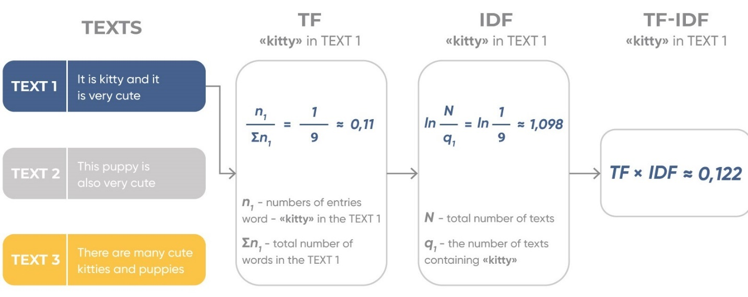

Figure 10 Example of TF-IDF

(K.P.Singh, 2018)

The TF-IDF weight is given to each word by calculating TF*IDF values.

$${w }_{i, j} ={ tf}_{ i,j} ×log\left(\frac{N}{{df }_{i}}\right)$$

${tf}_{u} =$ number of occurrences of i in j

${df}_{i} =$ number of documents containing i

$N =$ total number of documents

For generating the news vector, we calculate the values of the bigrams and represent the TF-IDF vector of that bigrams.

## N-Grams

A continuous sequence of n words from a given text is called an n-gram. A "unigram" is a size 1 n-gram; a "bigram" is a size 2, a "trigram" is a size 3, and so on. A model can hold more context with a bigger n.

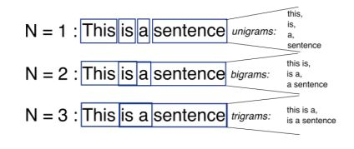

Figure 11 Example of n-grams

(K.P.Singh, 2018)

## Unigram

A 1-gram (or unigram) is a one-word sequence. the unigrams would simply be: “I”, “love”, “reading”, “blogs”, “about”, “data”, “science”, “on”, “Analytics”, “Vidhya”.

## Bigrams

Every sequence of two adjacent components in a string of tokens, which are generally letters, syllables, or words, is referred to as a bigram; they are referred to as n-grams for n=2. In various applications, such as computational linguistics, cryptography, and speech recognition, the frequency distribution of bigrams in a string is widely employed for basic statistical analysis of text. Gappy bigrams, also known as skipping bigrams, are word pairs that have gaps between them. Gappy bigrams having an explicit dependence link are called head word bigrams. Bigrams aid in calculating the conditional probability of a token based on the previous token.

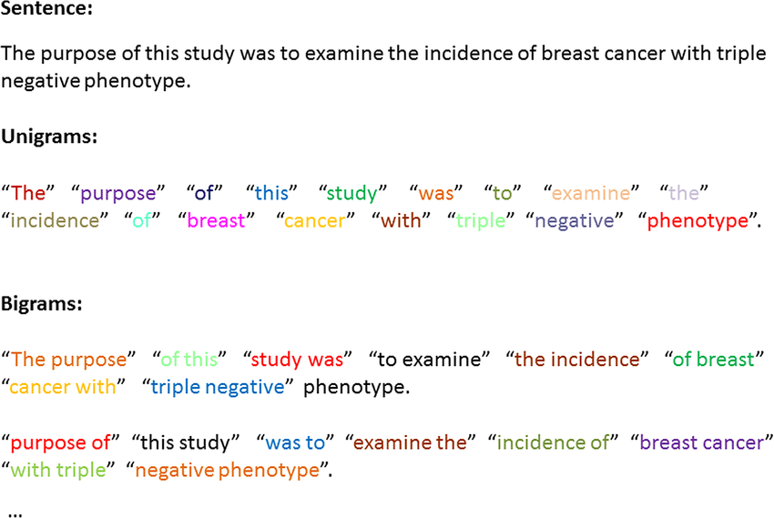

Figure 12 Example of bigram and unigram

(Rastegar-Mojarad, 2015)

## Shallow and Deep syntactical Analysis

Using the Spacy library, we created POS (part-of-speech) tags. For each of these tags, our POS characteristics will be encoded as TF-IDF values. According to a research article by Feng et al, POS tags are efficient in identifying fraudulent product evaluations, although they are not as effective as words. As a result, we add unigram/bigram functionalities to POS features.

We utilized the Stanford/Berkeley parser to produce CFG rules for the sentences and encoded these rules with TF-IDF values for each production rule for deep syntactical analysis.

## Semantic Analysis

Empath is a popular open-source resource for integrating semantic data (developed by Stanford). Empath is a dictionary of psychologically related terms organized into semantic groups. Several studies have used semantic analysis to create deception models using machine learning techniques, demonstrating that semantic information can aid in the automatic detection of dishonesty. Empath includes 194 semantic categories, including emotional tone (both good and negative), rage, and anxiety.

Each semantic class receives a score ranging from 0 to 100. The lexicon we get is converted to a TF-IDF vector by taking the score for a semantic class (like nervousness) as its frequency.

## Combining features to form final news vector

We considered 3 methods for generating feature vectors:

* 1. TF-IDF bigram vector of the news article.
  2. Feature Vector generated by Syntax Analysis of the news article.
  3. Feature Vector generated by the semantic analysis of the news article. After generating these features and generating their individual feature vector, we have to combine these features to form the final news vector on which classification is performed.

The method we approached for combining the feature vectors is

* 1. Take the most important features for the 3 feature vectors.
  2. Assign weights to each vector and then take the weighted combination of the 3 feature vectors to generate the final feature vector. If x is the weight corresponding to the first feature vector, y for the second, and 1-x-y for the third. The final feature vector will be the linear combination of these feature vectors multiplied by their corresponding weights.

## List of Text Preprocessing steps

We executed a series of steps under each component based on the broad outline above.

* Merging of fake and True data frame
* Removal of “title”, “subject” and “date” columns
* Random shuffling of the data frame
* Convert text into lowercase, removal of extra space, special characters, url and links
* Defining dependent and independent variable
* Splitting the dataset into training and testing set
* Convert text into vectors

## Merging of fake and True data frame

Since the data frame are different, we merge the fake and true news data frame as one

df_marge = pd.concat([df_fake, df_true], axis =0 )

df_marge.head(10)

## Removal of “title”, “subject” and “date” columns

We remove the title, subject and date columns since we have to remove noise

df = df_marge.drop(["title", "subject","date"], axis = 1)

df.isnull().sum()

## Random shuffling of the data frame

We random shuffle the data frame, that is the mixture of both true and false data frame.

df = df.sample(frac = 1)

df.head()

df.reset_index(inplace = True)

df.drop(["index"], axis = 1, inplace = True)

df.columns

df.head()

## Convert text into lowercase, removal of extra space, special characters, url and links

We remove the lowercase, extra space, special characters, url and links, this is done to remove noise from the data.

def wordopt(text):

    text = text.lower()

    text = re.sub('\[.*?\]', '', text)

    text = re.sub("\\W"," ",text)

    text = re.sub('https?://\S+|www\.\S+', '', text)

    text = re.sub('<.*?>+', '', text)

    text = re.sub('[%s]' % re.escape(string.punctuation), '', text)

    text = re.sub('\n', '', text)

    text = re.sub('\w*\d\w*', '', text)

    return text

df["text"] = df["text"].apply(wordopt)

## Defining dependent and independent variable

We differentiated between the class and text.

x = df["text"]

y = df["class"]

## Splitting the dataset into training and testing set

We split the set into two, that is the training and data set.

x_train, x_test, y_train, y_test = train_test_split(x, y, test_size=0.25)

## Convert text into vectors

We convert the text into vectors such that we can apply numeric machine learning

from sklearn.feature_extraction.text import TfidfVectorizer

vectorization = TfidfVectorizer()

xv_train = vectorization.fit_transform(x_train)

xv_test = vectorization.transform(x_test)

## Classification

After generating the news feature vector, now we classify the vector to whether it is fake or real. We aim to use the following classification algorithms for the purpose of classification:

### Naïve Bayes

The supervised learning method Naive Bayes is used for classification. It is based on the Bayes theorem, which assumes that characteristics are unrelated.

It estimates the likelihood of each class and selects the class with the highest probability as the output.

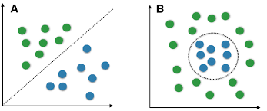

Figure 13 Example of a naive bayes

(Raschka, 2014)

**Gradient Boost Classifier**

Gradient boosting is one of the boosting algorithms it is used to minimize bias error of the model. It is a technique used to tackle classification and regression problems. It is a sequential ensemble learning technique in which the model's performance improves with time. The model is created in a stage-by-stage manner using this procedure. It infers the model by allowing an absolute differentiable loss function to be optimized. A new model is constructed as each weak learner is added, giving a more precise estimation of the response variable. Gradient boosting is a very reliable method for building predictive models. It is applicable to a variety of risk functions and improves the model's forecast accuracy. It also solves multicollinearity problems with high correlations between predictor variables.

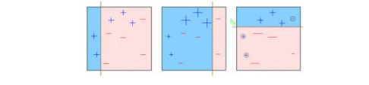

Figure 14 Example of gradient boost classifier

(Chu, n.d.)

**Random Forest Classifier**

Random Forest (RF). Random forest (RF) is an advanced form of decision trees (DT) which is also a supervised learning model. RF consists of large number of decision trees working individually to predict an outcome of a class where the final prediction is based on a class that received majority votes. The error rate is low in random forest as compared to other models, due to low correlation among trees. Our random forest was trained using different parameters i.e., different numbers of estimators were used in a grid search to produce the best model that can predict the outcome with high accuracy. there are multiple algorithms to decide a split in a decision tree based on the problem of regression or classification.

Random Forest = Bagging with decision tree as base model + feature bagging

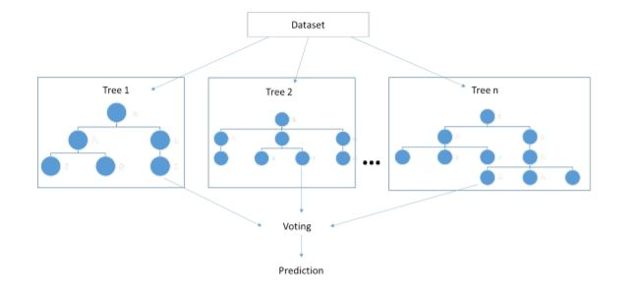

Figure 15 Example of random forest classification

(K.P.Singh, 2018)

# CHAPTER FOUR

# SIMULATION AND DISCUSSION

## Performance metrics

To evaluate the performance of algorithms, we used different metrics. Most of them are based on the confusion matrix. Confusion matrix is a tabular representation of a classification model performance on the test set, which consists of four parameters: true positive, false positive, true negative, and false negative

## Accuracy

Accuracy is often the most used metric representing the percentage of correctly predicted observations, either true or false. To calculate the accuracy of a model performance, the following equation can be used:

$$Accuracy = \frac{Tp + TN}{TP + TN + FP + FN}$$

In most circumstances, a model with a high accuracy value is a good model, but because we're training a classification model in this case, an item that was predicted is not a good model. False positives can occur when something appears to be true when it isn't.  Similarly, if an article was foreseen, it may have detrimental implications.  This can establish trust because it was marked as fake despite containing genuine material. As a result, we've employed three more metrics, taking into consideration the observation that was erroneously categorized, that is F1-score, precision, and recall.

## Recall

Recall represents the total number of positive classifications out of true class. In our case, it represents the number of articles predicted as true out of the total number of true articles.

|  |  |  |
| --- | --- | --- |
|  | Predicted Time | Predicted False |
| Actual True | True Positive (TP) | False Negative (FN) |
| Actual False | False Positive (TP) | True Negative (TN) |

Figure 16 Confusion Metrics

$$Recall = \frac{Tp }{TP + FN}$$

## Precision

Precision score, on the other hand, is the ratio of true positives to all real occurrences predicted. Precision in this example refers to the number of articles tagged as true out of all the positively predicted (true) articles:

$$Precision = \frac{Tp }{TP + FP}$$

## F1-Score

The trade-off between precision and recall is represented by the F1-score. It calculates the harmonic mean of each pair of numbers. Thus, it takes into account both false positive and false negative observations. The following formula can be used to determine the F1-score: $$F1-Score= 2\frac{Precision × Recall }{Precision × Recall}$$

These measures are widely used in the machine learning field and allow us to assess a classifier's effectiveness from many angles. Specifically, precision.

The similarity between anticipated and actual false news is measured. Precision is a metric that quantifies the percentage of all discovered false news that is labeled as fake news, solving the critical challenge of determining whether news is phony. Because false news datasets are frequently biased, a high level of accuracy can be attained by generating fewer positive predictions.

As a result, recall is used to gauge sensitivity, or the percentage of annotated false news items that are anticipated to be fake news. F1 is utilized to combine precision and recall, resulting in a prediction performance for detecting false news. The greater the value for Precision, Recall, F1, and Accuracy, the better the performance.

## DISCUSSION

We tested our model after doing extensive hyperparameter tuning. The model's goal is to be efficient in detecting fake and real and news in a set of datasets.

## COMPARISON FOR ALL MODELS

## CONFUSION MATRIX

The performance of a classification model is measured using a N x N matrix, where N is the number of target classes. The matrix compares the actual target values to the predictions of the machine learning model. This gives us a clear view of how well our classification model is performing and what kinds of mistakes it produces.

What we learn from matrix

* "Yes" and "no" are the two potential predicted classes. If we were forecasting the existence of an illness, "yes" would indicate that they have the condition, while "no" would indicate that they do not.
* A total of 165 predictions were produced by the classifier (e.g., 165 patients were being tested for the presence of that disease).
* The classifier correctly predicted "yes" 110 times and "no" 55 times out of 165 instances.
* In actuality, 105 of the participants in the study had the condition, while 60 do not.

The Basic terms:

true positives (TP)

These are cases in which we predicted yes (they have the disease), and they do have the disease.

true negatives (TN)

We predicted no, and they don't have the disease.

false positives (FP)

We predicted yes, but they don't actually have the disease. (Also known as a "Type I error.")

false negatives (FN)

We predicted no, but they actually do have the disease. (Also known as a "Type II error.")

The confusion matrix is automatically obtained by Python code using scikit learn when running the algorithm code in google colab platform.

## Null Error Rate

If you constantly anticipated the majority class, you'd be incorrect this many times. (In our example, the null error rate would be 60/165=0.36 since you would only be incorrect 60 times if you always predicted yes.) This might be a good benchmark against which to compare your classifier. The Accuracy Paradox shows that the best classifier for a certain application might occasionally have a greater mistake rate than the null error rate.

## Cohen's Kappa

This is essentially a comparison of how well the classifier performed against how well it would have done if it had been chosen at random. In other words, a model will have a high Kappa score if there is a significant gap between the accuracy and the null error rate.

## ROC Curve

This is a typical graph that illustrates a classifier's performance over all potential thresholds. The True Positive Rate (y-axis) is shown against the False Positive Rate (x-axis) when the threshold for allocating data to a particular class is changed.

The Confusion Matrix for all the algorithms are depicted below:

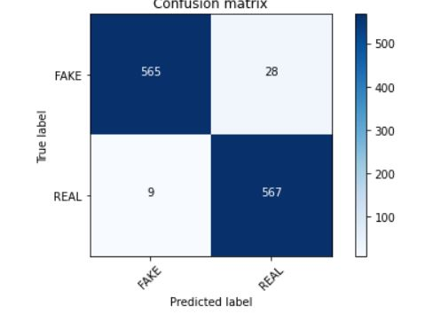

Figure 17 Confusion Matrix for multinominal Naive Bayes

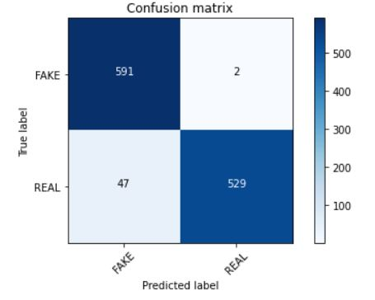

Figure 18 Confusion Matrix on Gradient Boosting

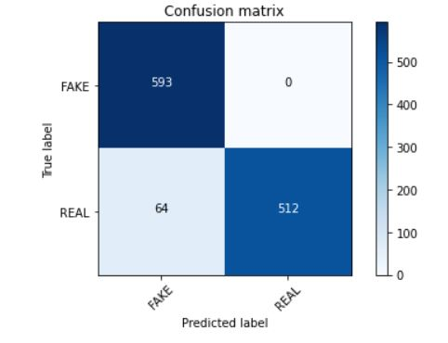

Figure 19 Confusion Matrix for Random Forest

## 

## ACCURACY

|  |  |
| --- | --- |
| Model | Accuracy |
| Multinominal Naïve Bayes | 96.7% |
| Gradient Boosting Classification | 96.6% |
| Random Forest Classification | 94.5% |

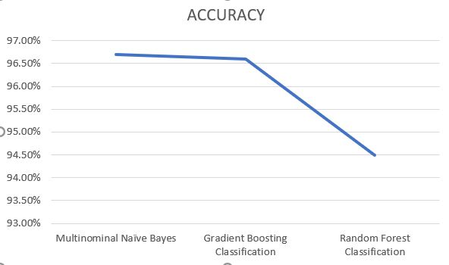

Figure graphical representation of the accuracy

Figure 19 expresses the accuracies of these algorithms. As shown the Multinominal Naïve Bayes has the highest with more than 96.7%, next is Gradient Boosting Classification and Random Forest with approximately 94.5% accuracy.

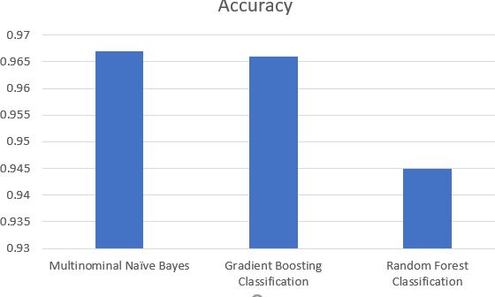

Figure 21 Accuracy result of all Models

(colab, n.d.)

### Classification Report

### 

Figure Classification Report on Gradient Boosting

(colab, n.d.)

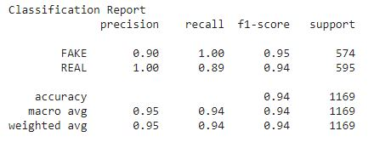

Figure Classification Report on Naive Bayes

(colab, n.d.)

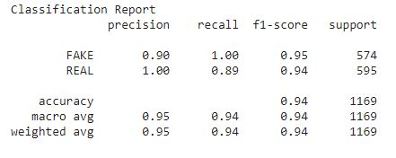

Figure Classification report of Random Forest

(colab, n.d.)

# CHAPTER FIVE

# SUMMARY, CONCLUSION AND RECOMMENDATION

The work of manually classifying news necessitates a thorough understanding of the domain as well as the ability to spot anomalies in the text. The topic of classifying false news articles using machine learning models and ensemble approaches was tackled in this study. The information we used in our research came from the Internet and consisted of news stories from various domains that covered the majority of the news rather than being expressly classified as political news. The main aim is to investigate the effectiveness of machine learning algorithms to detect fake news.

To achieve optimal accuracy, the learning models were trained and parameter-tuned. Some models have been shown to be more accurate than others. To compare the outcomes of each method, we used a variety of performance indicators. When compared to individual learners, the ensemble learners had a higher overall score on all performance indicators.

There are numerous outstanding issues in the detection of fake news that researchers must address. Identifying essential aspects involved in the distribution of news, for example, is a vital step in reducing the spread of fake news. To identify the primary sources engaged in the dissemination of fake news, graph theory and machine learning approaches can be used. Similarly, real-time fake news detection in videos could be a promising future avenue.

# REFERENCES

A. P. Bradley, R. P.-r.-R.-1. (2006). *Precision-recall operating characteristic (P-ROC) curves in imprecise environments,*. Retrieved from Ieeexplore: https://ieeexplore.ieee.org/abstract/document/1699797

Aldwairi, M., & Alwahedi, A. (2018). Detecting Fake News in Social Media Networks. *The 9th International Conference on Emerging Ubiquitous Systems and Pervasive Networks*, 215-222.

Allcott, H., & Gentzkow, M. (2017). Social Media and Fake News in the 2016 election. *Journal of Economics perspectives*, 211-236.

Allcott, H., & Gentzkow, M. (n.d.). Social Media and fake news in the 2016 election. *Journal of Economic Perspertives, 2*, 211-236.

Bhandari, A. (n.d.). Retrieved from Analytics Vidhya: https://www.analyticsvidhya.com/blog/2020/04/confusion-matrix-machine-learning/

Bhandari, A. (2020, April 17). *Everything you Should Know about Confusion Matrix for Machine Learning*. Retrieved from Analytics Vidhya: https://www.analyticsvidhya.com/blog/2020/04/confusion-matrix-machine-learning/

Brownlee, J. (2020, August 15). *A Gentle Introduction to the Gradient Boosting Algorithm for Machine Learning*. Retrieved from Machine Learning Mastery: https://machinelearningmastery.com/gentle-introduction-gradient-boosting-algorithm-machine-learning/

CKai Shu, S. W. (n.d.). *Exploiting Tri-Relationship for Fake News Detection.*

Club, U. M. (2017). *kaggle*. Retrieved from kaggle: https://www.kaggle.com/c/fake-news/overview

colab, G. (n.d.). *google colab*. Retrieved from google colab: https://colab.research.google.com/drive/1Gl2CB_-4_SFtk4RMTVin6tyac8i8rCEv#scrollTo=Gd04QOAl7Owd&uniqifier=2

*Complete Guide to Parameter Tuning in Gradient Boosting (GBM) in Python*. (n.d.). Retrieved from nttrungmt-wiki: https://sites.google.com/site/nttrungmtwiki/home/it/machine-lear/ensemble-learning/complete-guide-to-parameter-tuning-in-gradient-boosting-gbm-in-python

de Oliveira, N. R., Pisa, P. S., Lopez, M. A., de Medeiros, D. S., & Mattos, D. F. (2021). Identifying Fake News on Social Networks Based on Natural. *Information*.

H.G. Lewis and M, B. (2010, November 25). *A generalized confusion matrix for assessing area estimates from remotely sensed data*. Retrieved from International Journal of Remote Sensing: https://www.tandfonline.com/doi/abs/10.1080/01431160152558332

Hardman, E. B.-A. (n.d.). Simplifying the visualization of confuion matrix.

Iftikhar Ahmad, M. Y. (2020, September 16). *Hindawi*. Retrieved from Hindawi: https://www.hindawi.com/journals/complexity/2020/8885861/

Janez, C., & Risius, M. (2017). Automatic Detection of Fake News on Social Media Platforms. *PACIS 2017 Proceddings*, 261.

Junaed Younus Khan, M. T. (2019). A Benchmark Study on Machine Learning Methods for Fake News.

K.P.Singh, D. (2018). *Fake News Detection.*

Kai Shu, A. s. (2017, JUNE). *ACM DIGITAL LIBRARY*. Retrieved from ACM DIGITAL LIBRARY: https://dl.acm.org/doi/abs/10.1145/3137597.3137600

Knoll, A. N. (2013, December 04). *Gradient boosting machines, a tutorial*. Retrieved from frontiers in neurobotics: https://www.frontiersin.org/articles/10.3389/fnbot.2013.00021/full

Lakshmikumar, P. C. (2019). *Fake News Detection - A Deep Neural Network.*

Liu, Y., & Wu, Y.-F. B. (2018). Early Detection of Fake News on Social Media Through Propagation Path. *The Thirty-Second AAAI Conference on Artificial Intellifence(AAAI-18).* New Jersey .

Raschka, S. (2014). *Naive Bayes and Text Classification*. Retrieved from Sebastianraschka: https://sebastianraschka.com/Articles/2014_naive_bayes_1.html

Rastegar-Mojarad, M. &. (2015). *Application of Clinical Text Data for Phenome-Wide Association Studies (PheWASs)*. Retrieved from ResearchGate: https://www.researchgate.net/publication/271910222_Application_of_Clinical_Text_Data_for_Phenome-Wide_Association_Studies_PheWASs/citation/download

Risdal, M. (n.d.). *kaggle*. Retrieved from kaggle: https://www.kaggle.com/mrisdal/fake-news

Rish, I. (n.d.). An empirical study of the naive Bayes classifier.

S. I. Manzoor, J. S. (2019). *Fake News Detection Using Machine Learning approaches: A systematic Review*. Retrieved from IEEE: https://ieeexplore.ieee.org/abstract/document/8862770

Schmit, M. L. (2015). *ScienceDirect*. Retrieved from Machine Language: https://www.sciencedirect.com/topics/engineering/machine-language

Shu, K., & Liu, H. (2019, July). morgan and claypool publishers. *Synthesis Lectures on Data Mining and Knowledge Discovery, 11*, 1-129. Retrieved from morganclaypool.com: https://www.morganclaypool.com/doi/pdf/10.2200/S00926ED1V01Y201906DMK018

Shu, K., Amy, S., Suhang , W., Tang, J., & Huan, L. (n.d.). Fake News Detection on Social Media:. *SIGKDD Explorations, 19*(1), 22-36.

Shu, K., Sliva, A., Wang, S., Tang, J., & Liu, H. (2017). Fake News Detection on Social Media: A Data Mining Perspective. 22-36.

Silverman, C. (2016). *This analysis shows how fake election news stories outperformed real news on facebook.* Buzzfeed.

*Simple guide to confusion matrix terminology*. (2014, March 25). Retrieved from Data school: https://www.dataschool.io/simple-guide-to-confusion-matrix-terminology/

*sklearn.metrics.classification_report*. (n.d.). Retrieved from scikit learn: https://scikit-learn.org/stable/modules/generated/sklearn.metrics.classification_report.html

Stahl, K. (2018). *Fake news detection in social media.*

V, R. (2017). Deception detection and rumor debunking for social media. *HandBook of SOcial Media*.

V. M. Krešňáková, M. S. (2019). Deep learning methods for Fake News detecti. *IEEE*.

Wiener, A. L. (2002). Classification and Regression by randon Forest.

Z Khanam, B. N. (2020). Fake News Detection Using Machine Learning Approaches. *IOPSCIENCE*.

Z Khanam, B. N. (2021). Fake News Detection Using Machine Learning Approaches. *IOP Conference Series: Materials Science and Engineering*.

# APPENDIX